1) Create one EC2 instance with httpd installed using a Terraform script.

✅ Create an AWS EC2 instance
✅ Install Apache (httpd) automatically
✅ Use Terraform properly
✅ Run everything from Visual Studio Code

Architecture
Terraform will:
- Connect to AWS
- Create Security Group
- Launch EC2 instance
- Install Apache (httpd) using User Data
- Open website on port 80

Prerequisites
Install these first:
1. Install Terraform
Download from:
Terraform Official Website
Check:
terraform -version

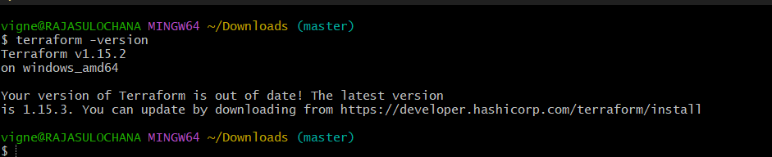

2. Install AWS CLI
Download:
AWS CLI Official Website
Check:
aws –version
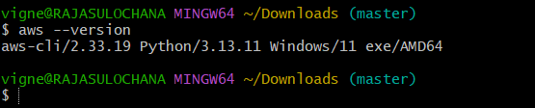

3. Configure AWS Credentials
Run:
aws configure
Enter:
AWS Access Key ID
AWS Secret Access Key
Region = ap-south-1
Output format = json
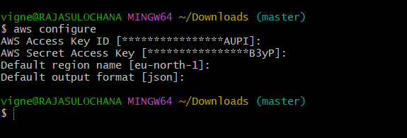

Step 1 — Open VS Code
Create folder:
terraform-ec2-httpd
Open folder in VS Code.
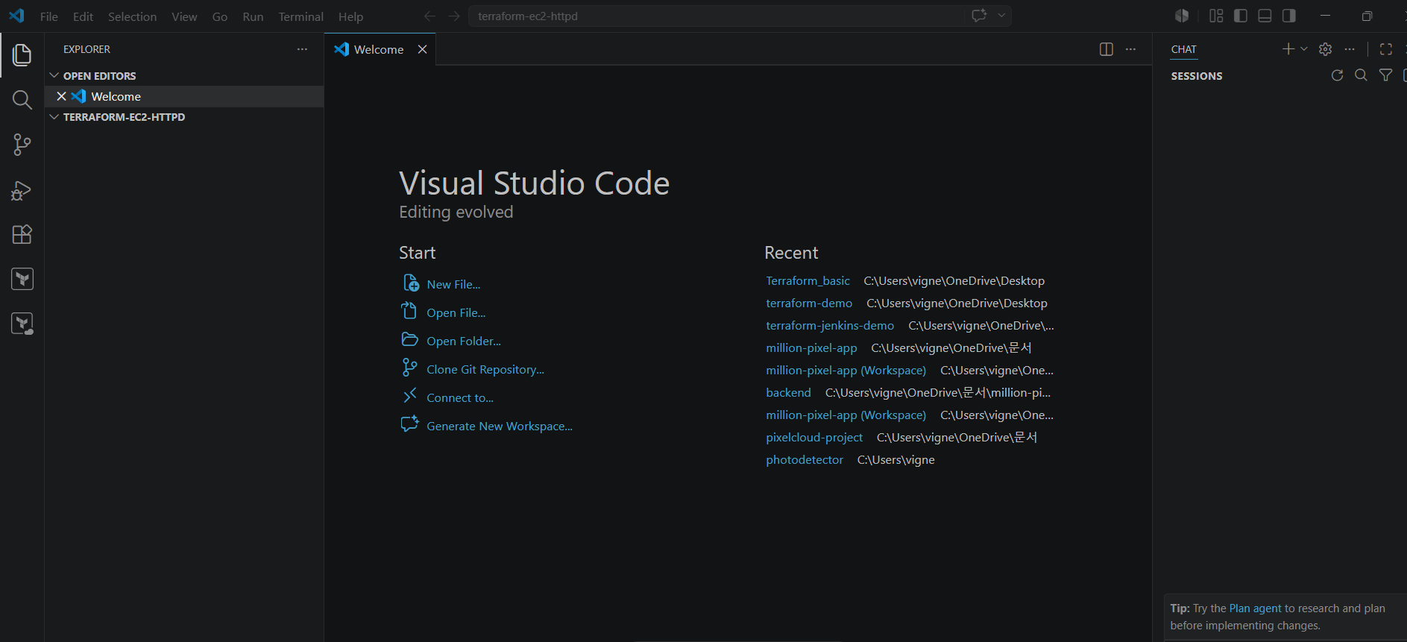

Step 2 — Create Files
Create these files:
main.tf
variables.tf
outputs.tf

Step 3 — Write main.tf
Paste this:
provider "aws" {
region = "eu-north-1"
}
# Security Group
resource "aws_security_group" "web_sg" {
name = "web-security-group"
ingress {
from_port = 22
to_port = 22
protocol = "tcp"
cidr_blocks = ["0.0.0.0/0"]
}
ingress {
from_port = 80
to_port = 80
protocol = "tcp"
cidr_blocks = ["0.0.0.0/0"]
}
egress {
from_port = 0
to_port = 0
protocol = "-1"
cidr_blocks = ["0.0.0.0/0"]
}
}
# EC2 Instance
resource "aws_instance" "web_server" {
ami = "ami-063f61adbae382edf"
instance_type = "t3.micro"
security_groups = [aws_security_group.web_sg.name]
user_data = <<-EOF
#!/bin/bash
yum update -y
yum install httpd -y
systemctl start httpd
systemctl enable httpd
echo "<h1>Apache Installed using Terraform</h1>" > /var/www/html/index.html
EOF
tags = {
Name = "Terraform-HTTPD-Server"
}
}

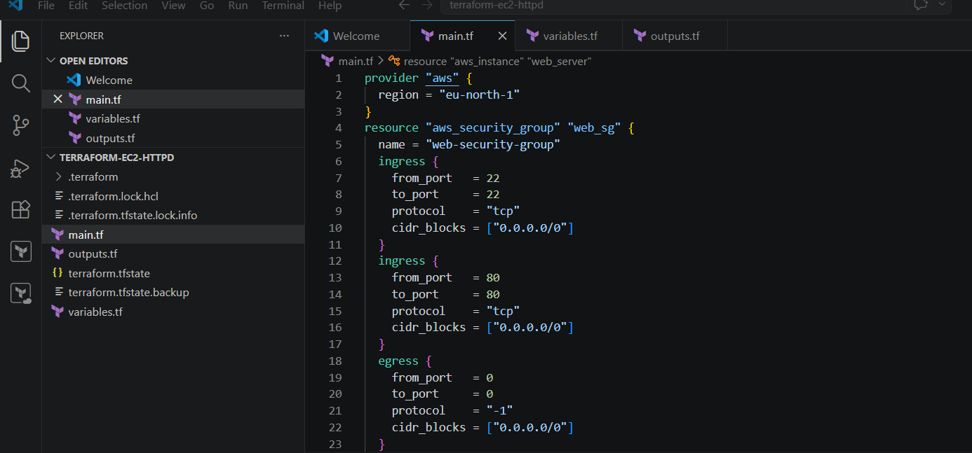
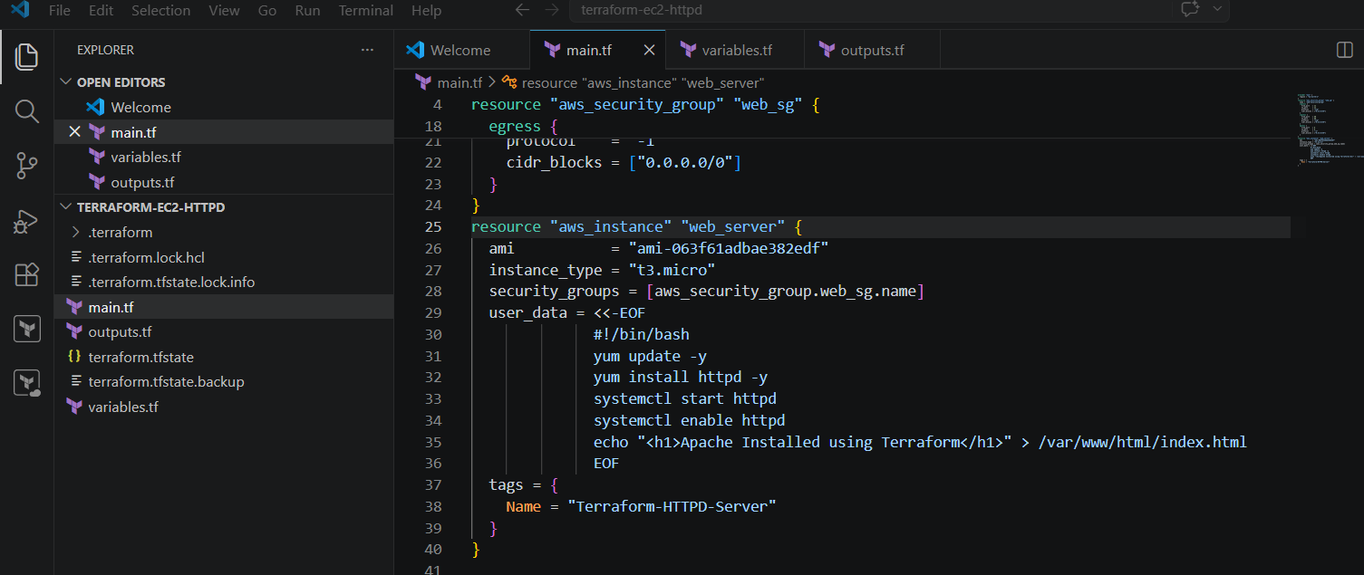

Step 4 — Write variables.tf
variable "region" {
default = "eu-north-1"
}

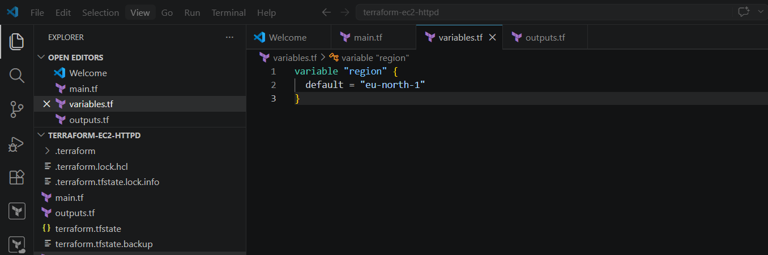

Step 5 — Write outputs.tf
output "public_ip" {
value = aws_instance.web_server.public_ip
}
output "public_dns" {
value = aws_instance.web_server.public_dns
}
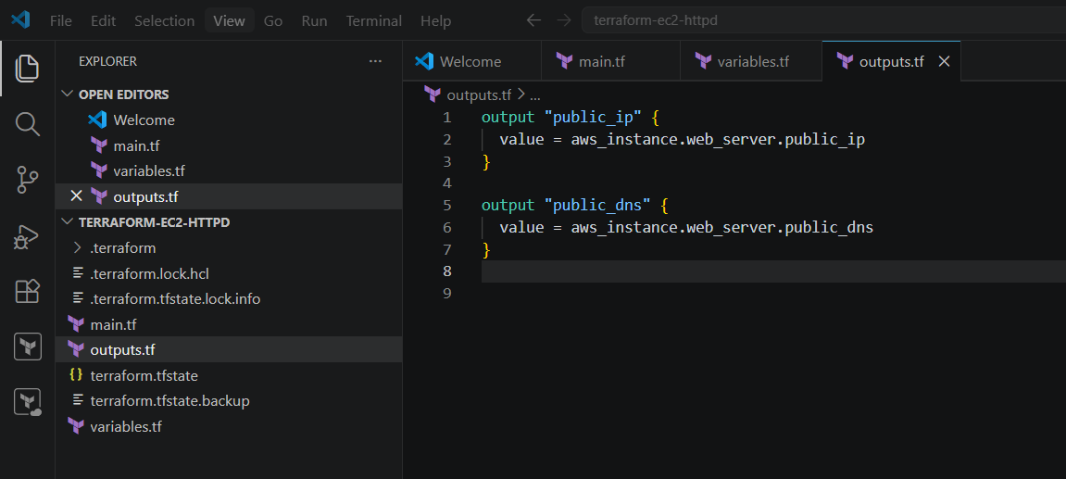

Step 6 — Initialize Terraform
Open terminal inside VS Code:
terraform init
You’ll see:
Terraform has been successfully initialized!
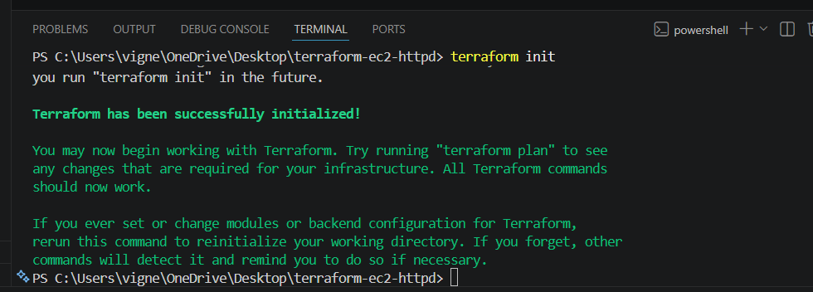

Step 7 — Validate Code
terraform validate
Expected:
Success! The configuration is valid.
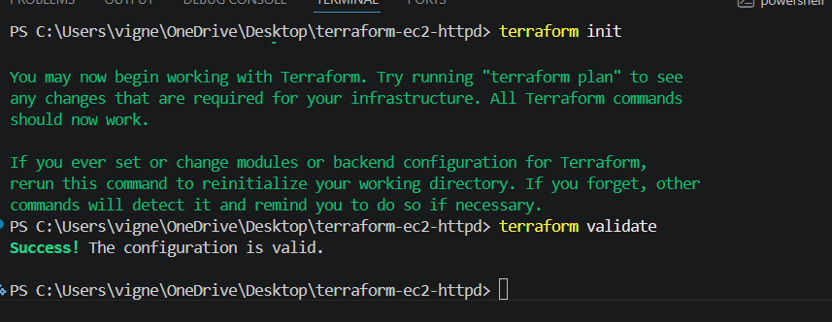

Step 8 — Preview Infrastructure
terraform plan
Terraform shows what resources will be created.
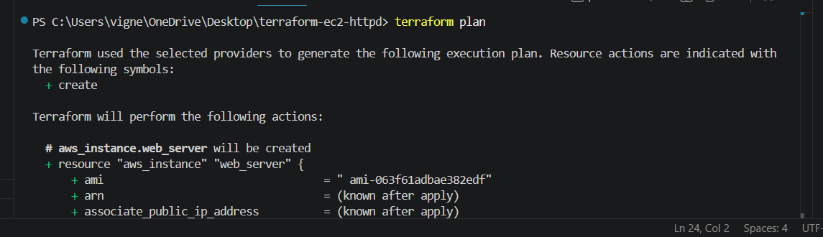
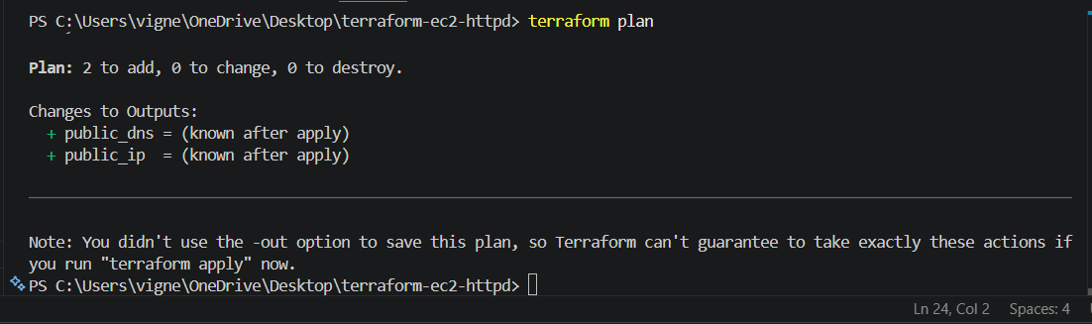

Step 9 — Create EC2 Instance
terraform apply
Type:
yes
Terraform creates:
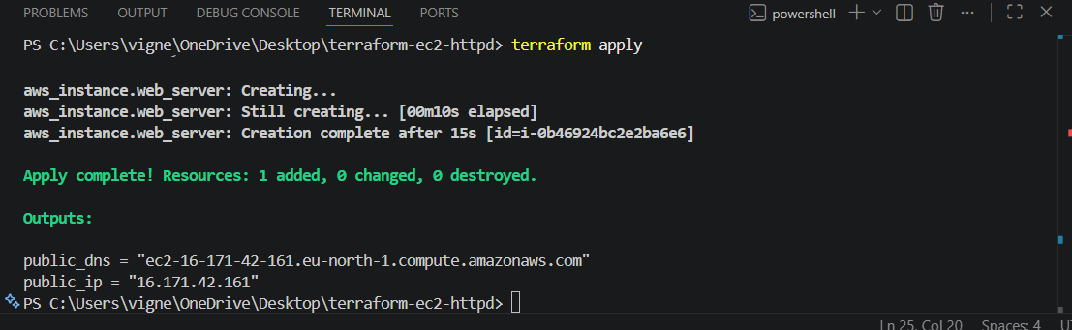
✅ Security Group
✅ EC2 Instance
✅ Apache Web Server

Step 10 — Get Public IP
Terraform outputs:
public_ip = xx.xx.xx.xx
Open browser:
http://PUBLIC_IP
http://16.171.42.161/

You’ll see:
Apache Installed using Terraform
Done!

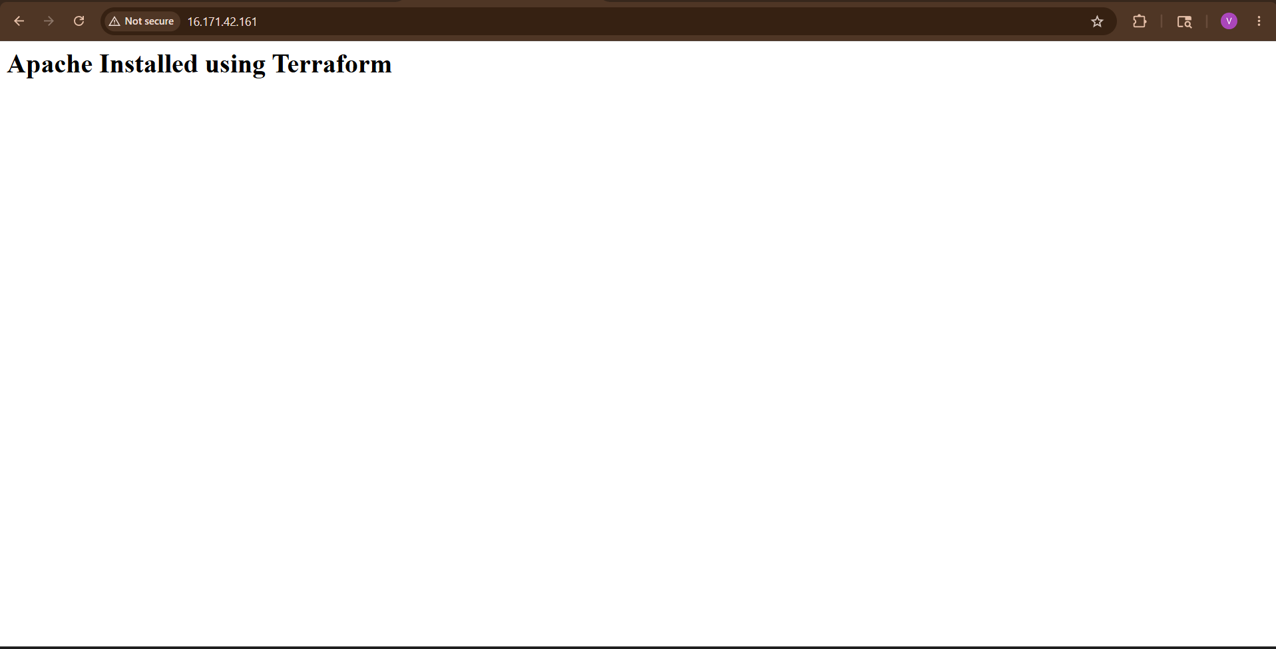

Step 11 — Verify in AWS Console
Go to:
AWS Console
Check:
- EC2 Instance
- Security Groups
- Public IP
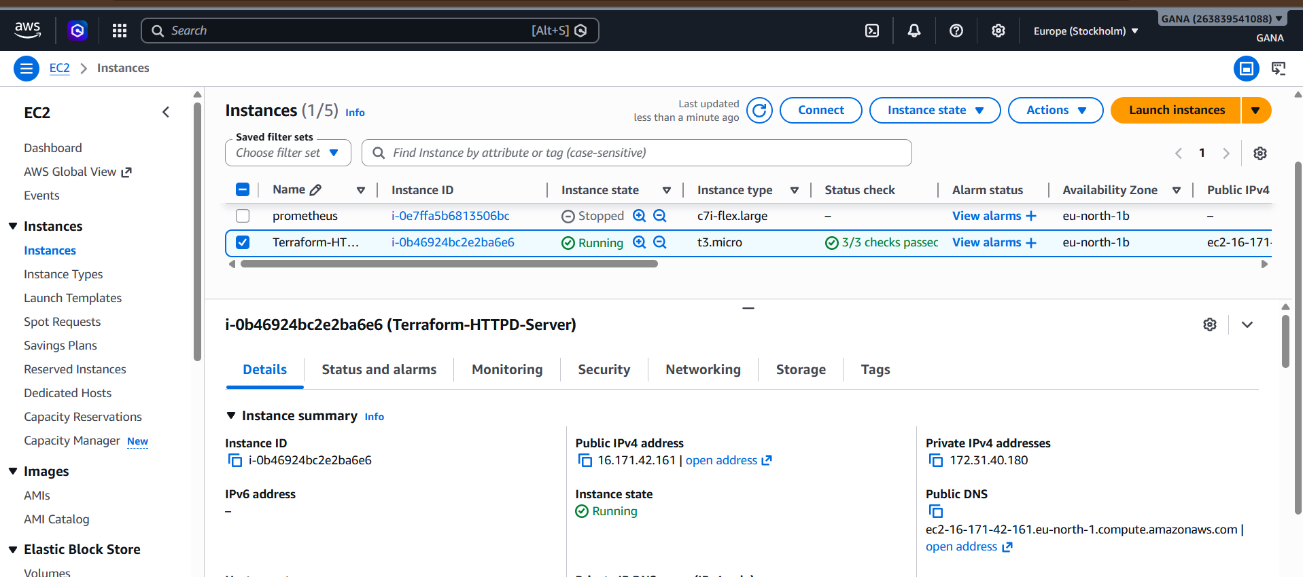

Step 12 — Destroy Resources (Important)
To avoid AWS charges:
terraform destroy
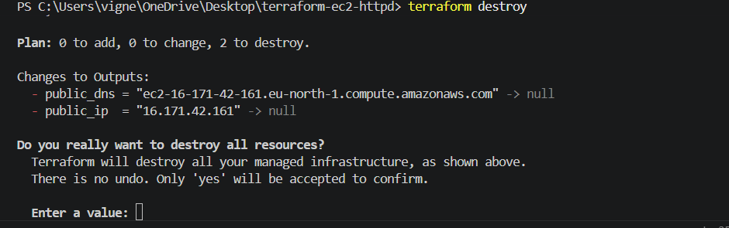

Type:
Yes

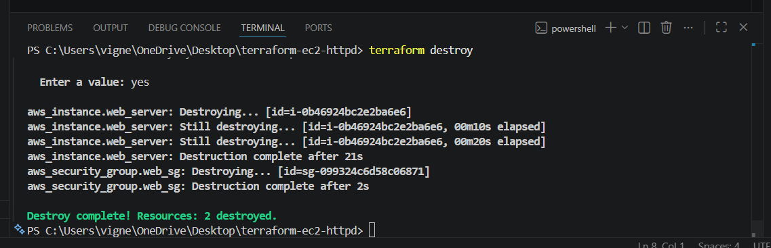

Project Structure
terraform-ec2-httpd/
│
├── main.tf
├── variables.tf
├── outputs.tf
├── terraform.tfstate
├── .terraform/

What Each Part Does
Resource |  | Purpose
provider "aws" |  | Connects Terraform to AWS
aws_security_group |  | Opens ports 22 & 80
aws_instance |  | Creates EC2
user_data |  | Installs Apache automatically
output |  | Displays public IP

2) Set up S3 as backend for task 3.

Goal
Using Terraform:
✅ Create S3 bucket
✅ Store Terraform state in S3
✅ Use only main.tf

Important Concept
Terraform cannot store state in S3 before the bucket exists.
So we do this in 2 phases:
Phase | Purpose
Phase 1 | Create S3 bucket locally
Phase 2 | Configure backend using that bucket

STEP 1 — Create Project Folder
terraform-s3-backend
Open in VS Code.

STEP 2 — Create main.tf
First create ONLY the S3 bucket.
Paste this:
provider "aws" {
region = "eu-north-1"
}
# Create S3 Bucket
resource "aws_s3_bucket" "tf_state" {
bucket = "vignesh-tf-backend-bucket-2026"
tags = {
Name = "Terraform Backend Bucket"
}
}

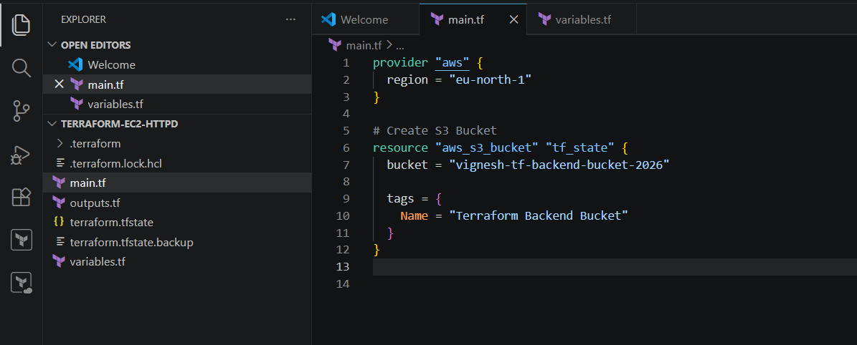
Bucket name must be globally unique.
If error comes:
BucketAlreadyExists
Change bucket name.
Example:
bucket = "vignesh-backend-12345"

STEP 3 — Initialize Terraform
terraform init
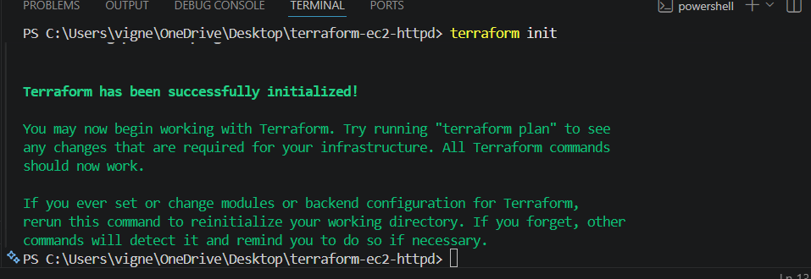

STEP 4 — Create S3 Bucket
terraform apply
Type:
yes
Terraform creates S3 bucket.
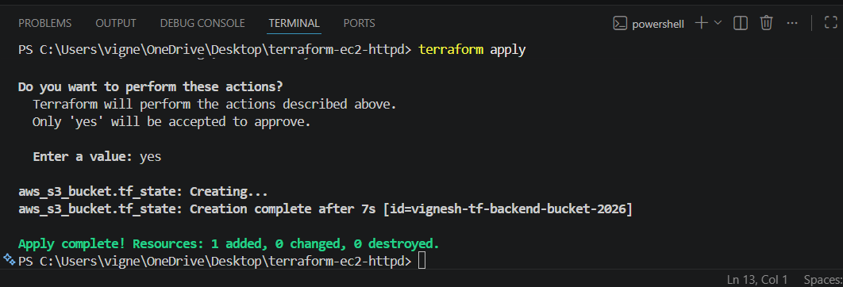
Verify In S3
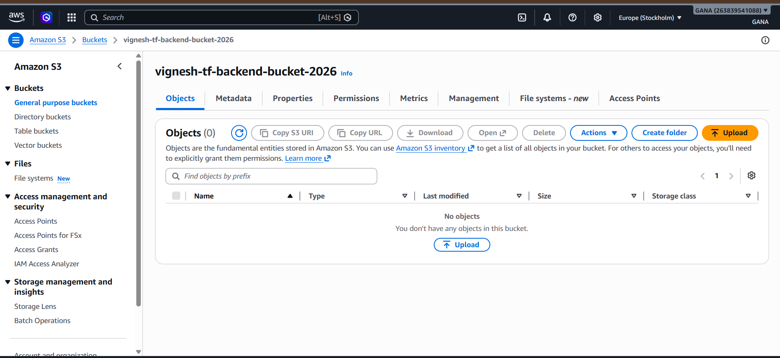

STEP 5 — NOW Add Backend Block
After bucket creation, modify same main.tf.
Add this block at TOP:
terraform {
backend "s3" {
bucket = "vignesh-tf-backend-bucket-2026"
key = "terraform.tfstate"
region = "eu-north-1"
}
}
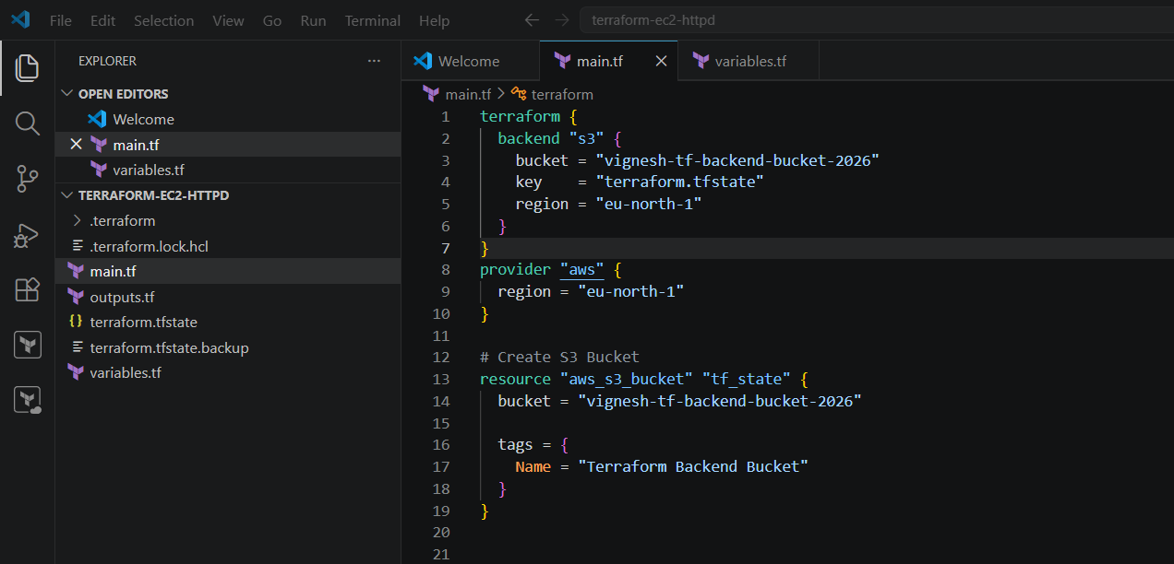

Final main.tf

terraform {
backend "s3" {
bucket = "vignesh-tf-backend-bucket-2026"
key = "terraform.tfstate"
region = "ap-south-1"
}
}
provider "aws" {
region = "ap-south-1"
}
resource "aws_s3_bucket" "tf_state" {
bucket = "vignesh-tf-backend-bucket-2026"
tags = {
Name = "Terraform Backend Bucket"
}
}


STEP 6 — Reinitialize Terraform
Run:
terraform init
Terraform asks:
Do you want to copy existing state to the new backend?
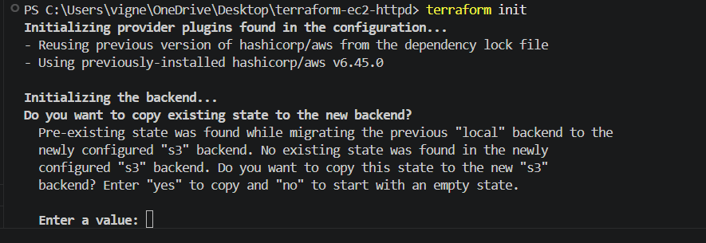

Type:
Yes
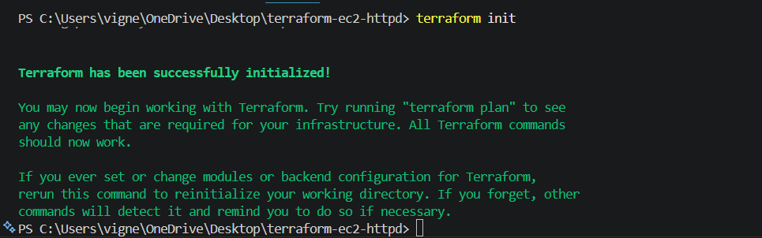

STEP 7 — Verify Backend Works
Run:
terraform plan
Now Terraform state is stored in S3 🎉
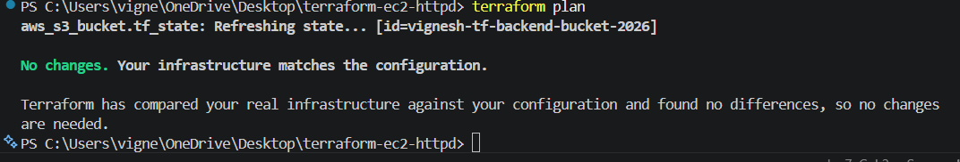

Verify in AWS Console
Go to:
AWS S3 Console
Open bucket.
You’ll see:
terraform.tfstate
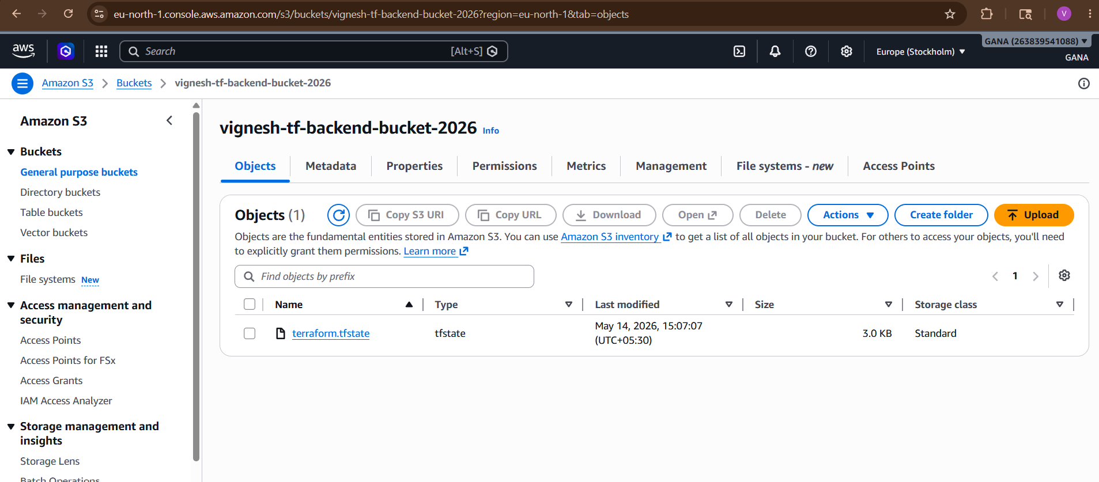
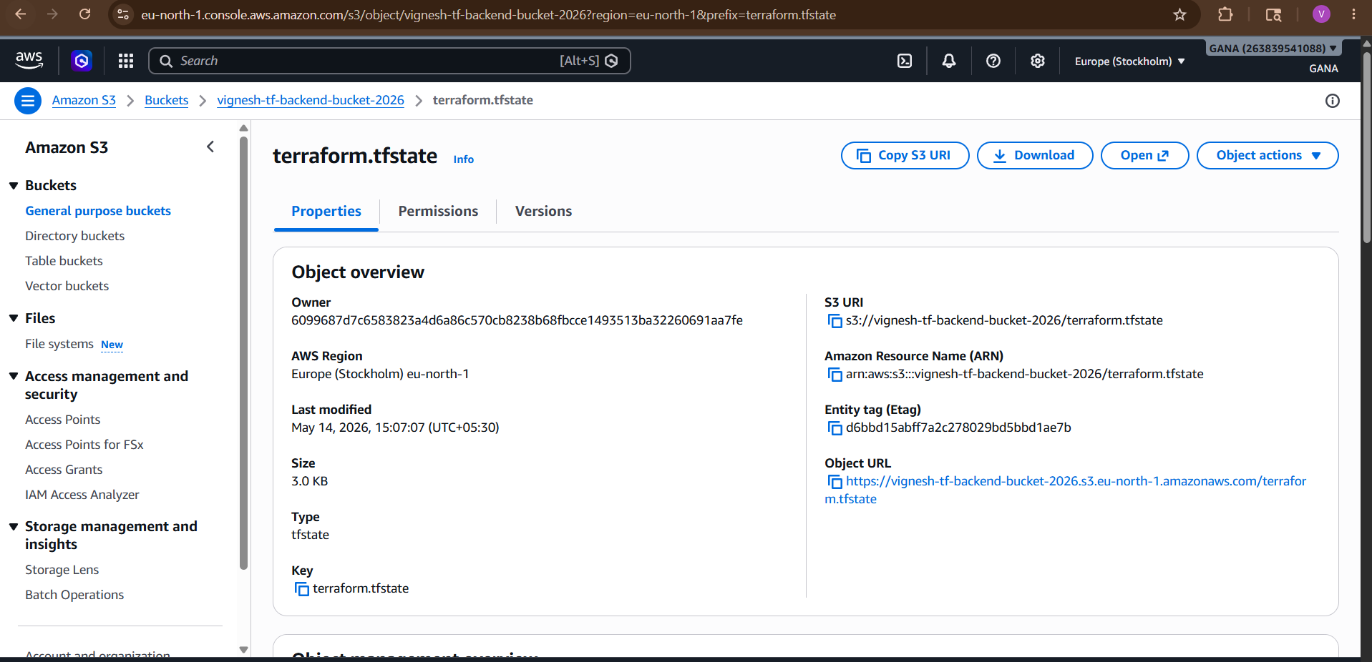

Real-Time Production Structure
Usually companies use:
Terraform
↓
S3 Backend
↓
DynamoDB Locking

3) Set up DynamoDB locking for task 3.

Why DynamoDB Locking?
Imagine:
Dev1 → terraform apply
Dev2 → terraform apply
Both modify same state file at same time
Result:
State corruption
Infrastructure conflicts

DynamoDB Locking Solves This
Terraform creates a lock in DynamoDB table.
While one person runs Terraform:
✅ Others must wait
✅ Prevents corruption
✅ Safe collaboration

Architecture
Terraform
│
├── S3 Backend (State File)
│
└── DynamoDB (State Locking)

STEP 1 — Open Existing main.tf
Current setup already has:
✅ S3 backend
✅ EC2 instance
Now we add DynamoDB.

STEP 2 — Add DynamoDB Table Resource
Add this BELOW provider block.
resource "aws_dynamodb_table" "terraform_locks" {
name = "terraform-lock-table"
billing_mode = "PAY_PER_REQUEST"
hash_key = "LockID"
attribute {
name = "LockID"
type = "S"
}
tags = {
Name = "Terraform Lock Table"
}
}

STEP 3 — Update Backend Block
Modify your backend block like this:
terraform {
backend "s3" {
bucket = "vignesh-tf-backend-bucket-2026"
key = "terraform.tfstate"
region = "ap-south-1"
dynamodb_table = "terraform-lock-table"
}
}

Final main.tf

terraform {
backend "s3" {
bucket = "baba-tf-backend-bucket-2026"
key = "terraform.tfstate"
region = "eu-north-1"
use_lockfile = true
}
}
provider "aws" {
region = "eu-north-1"
}
resource "aws_dynamodb_table" "terraform_lock" {
name = "terraform-lock-table"
billing_mode = "PAY_PER_REQUEST"
hash_key = "LockID"
attribute {
name = "LockID"
type = "S"
}
tags = {
Name = "Terraform Lock Table"
}
}
resource "aws_instance" "web_server" {
ami = "ami-063f61adbae382edf"
instance_type = "t3.micro"
user_data = <<-EOF
#!/bin/bash
yum update -y
yum install httpd -y
systemctl start httpd
systemctl enable httpd
echo "<h1>Apache Installed using Terraform</h1>" > /var/www/html/index.html
EOF
tags = {
Name = "Terraform-HTTPD-Server"
}
}
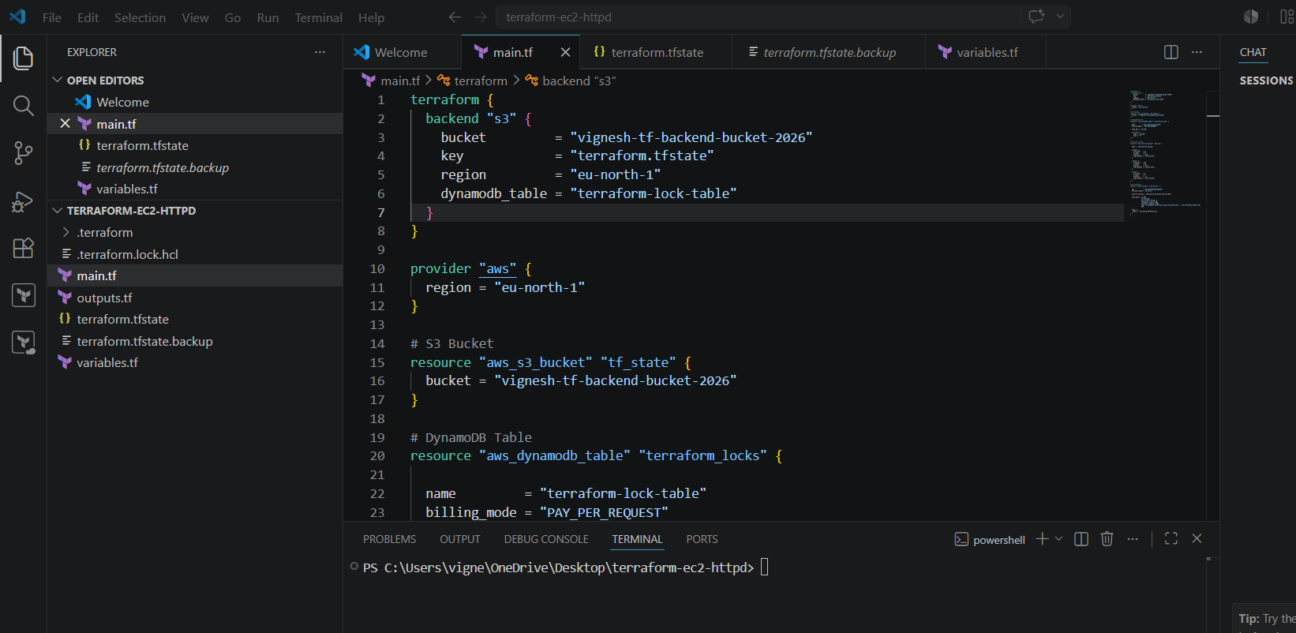
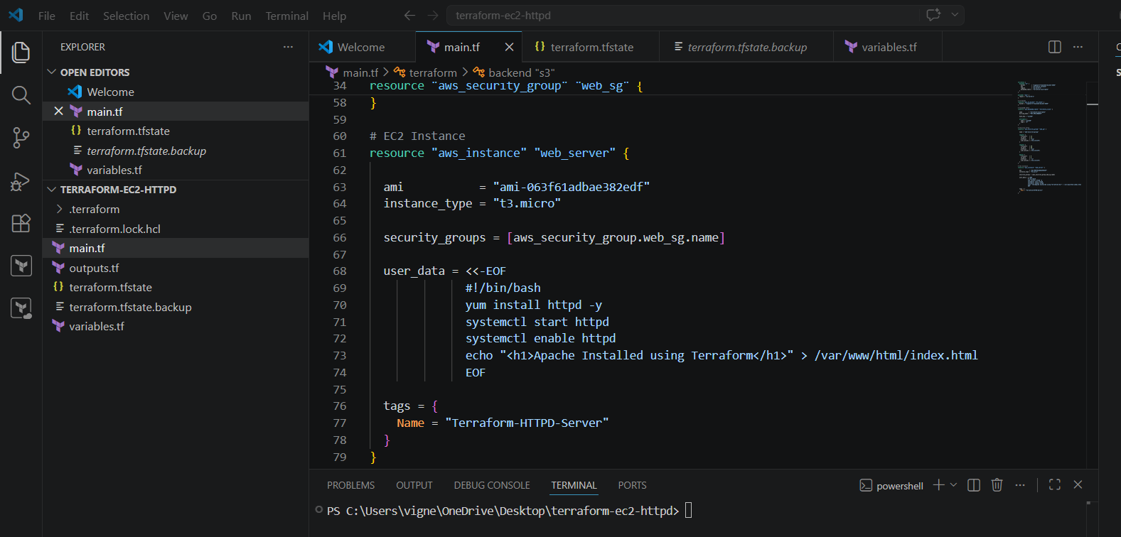

STEP 4 — Run terraform init Again
terraform init -reconfigure
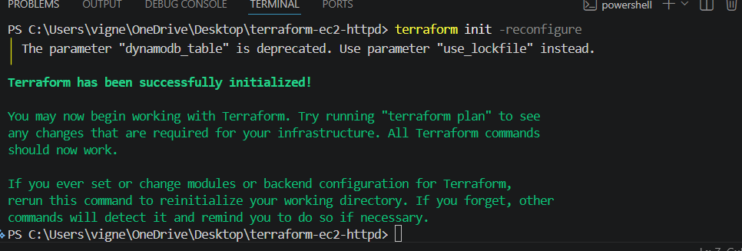
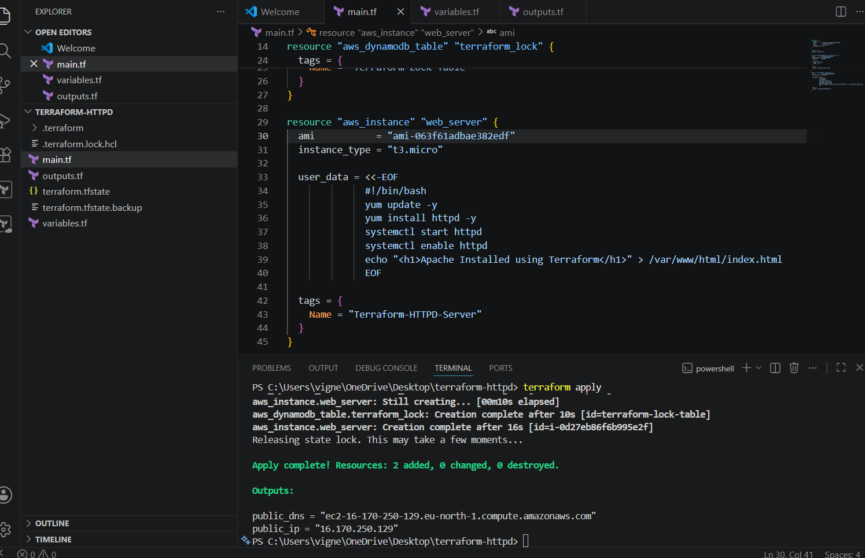

IMPORTANT
You may get:
ResourceNotFoundException:
Requested resource not found
Why?
Because backend tries to use DynamoDB table BEFORE it exists.

Correct Real-Time Method
First Create DynamoDB Table
Temporarily COMMENT backend block:
# terraform {
# backend "s3" {
# bucket = "vignesh-tf-backend-bucket-2026"
# key = "terraform.tfstate"
# region = "ap-south-1"
# dynamodb_table = "terraform-lock-table"
# }
# }

STEP 5 — Create Table
Run:
terraform apply
Type:
yes
This creates:
✅ DynamoDB table
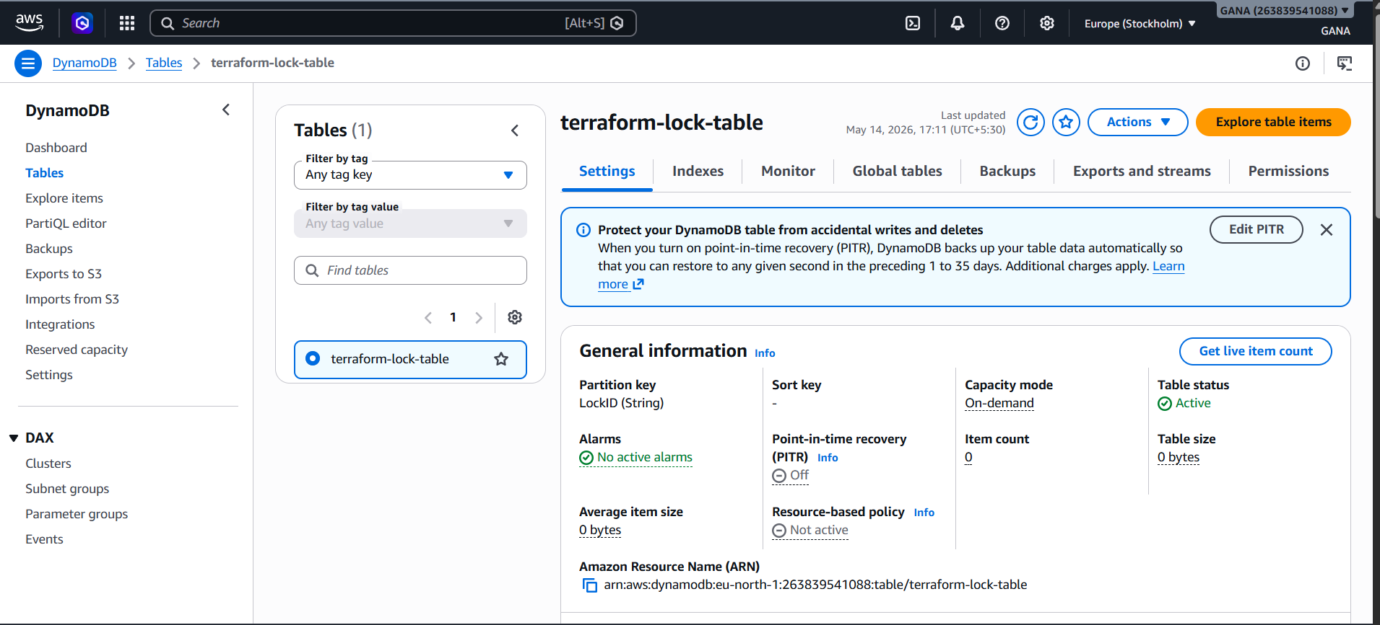

STEP 6 — Re-enable Backend Block
Uncomment backend block.

STEP 7 — Reinitialize Terraform
terraform init
Terraform configures:
✅ S3 backend
✅ DynamoDB locking

STEP 8 — Test Locking
Run:
terraform apply
During execution Terraform creates lock.

You’ll see:
Acquiring state lock...
Locking working successfully.

Verify in AWS Console
Go to:
DynamoDB
AWS DynamoDB Console
You’ll see:
terraform-lock-table
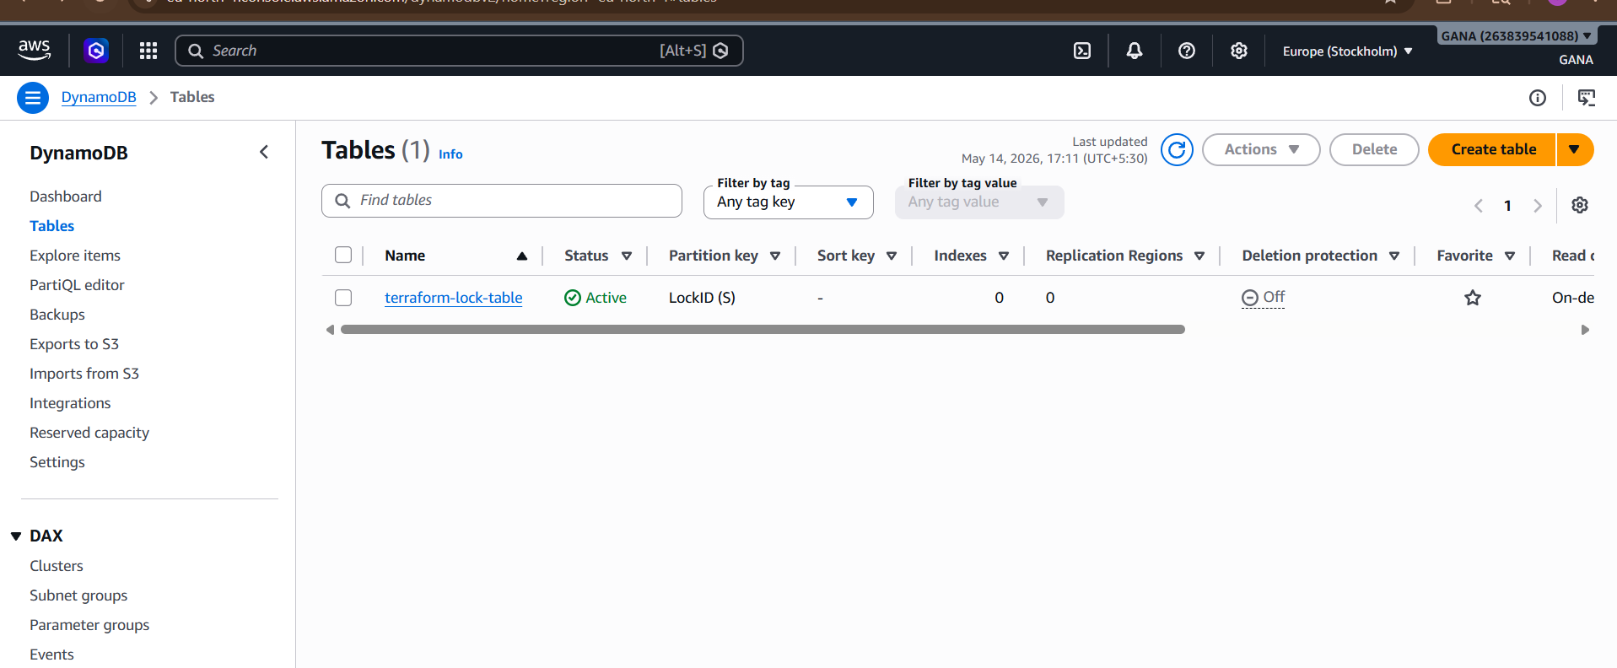

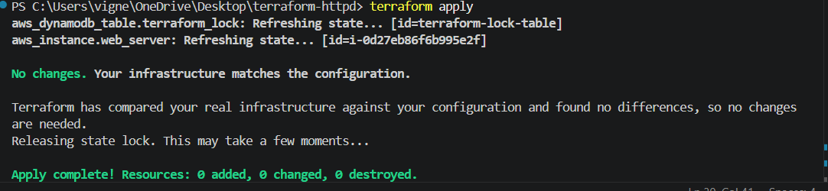

Your setup is now fully working.
From your output:
Releasing state lock...
✅ DynamoDB locking is working
✅ S3 backend is working
✅ EC2 instance is running
✅ Terraform state management successful
And this confirms Terraform successfully used:
aws_dynamodb_table.terraform_lock
during apply.
http://ec2-16-170-250-129.eu-north-1.compute.amazonaws.com/

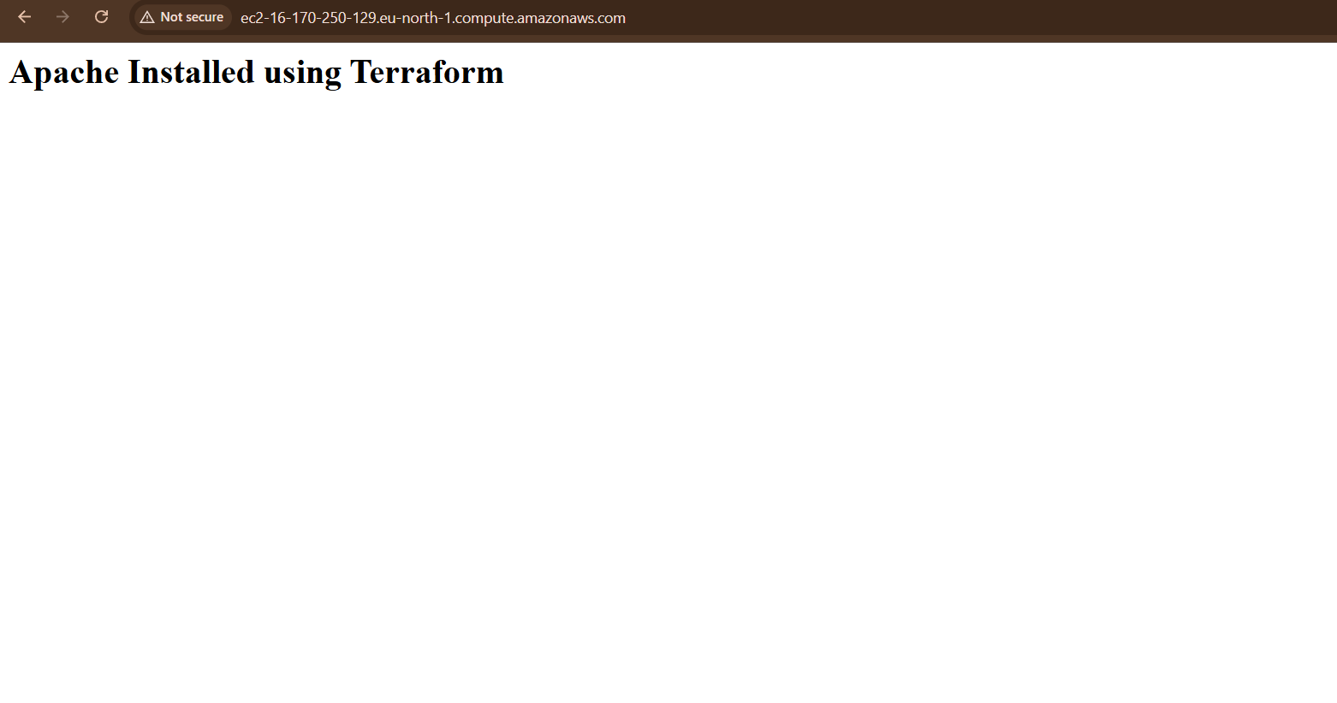

Real-Time Production Flow
Developer
↓
Terraform
↓
S3 Backend (State File)
↓
DynamoDB (Locking)

